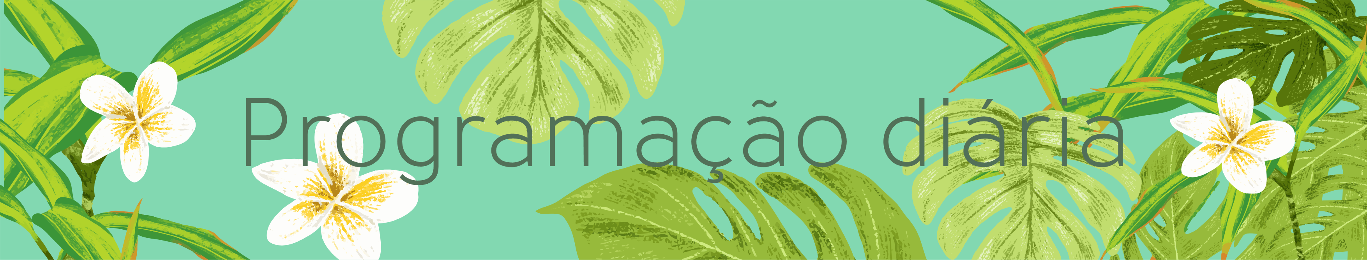

|  |  |  |  |  |  |  |
| --- | --- | --- | --- | --- | --- | --- |
| Segunda-Feira | Terça-feira | Quarta-feira | Quinta-feira | Sexta-feira | Sábado | Domingo |
|  |  |  |  |  |  |  |
|  |  |  |  |  |  |  |
|  |  |  |  |  |  |  |
|  |  |  |  |  |  |  |
|  |  |  |  |  |  |  |
|  |  |  |  |  |  |  |
|  |  |  |  |  |  |  |
|  |  |  |  |  |  |  |
|  |  |  |  |  |  |  |
|  |  |  |  |  |  |  |
|  |  |  |  |  |  |  |